JDBC:

* JDBC stands for Java Database Connectivity

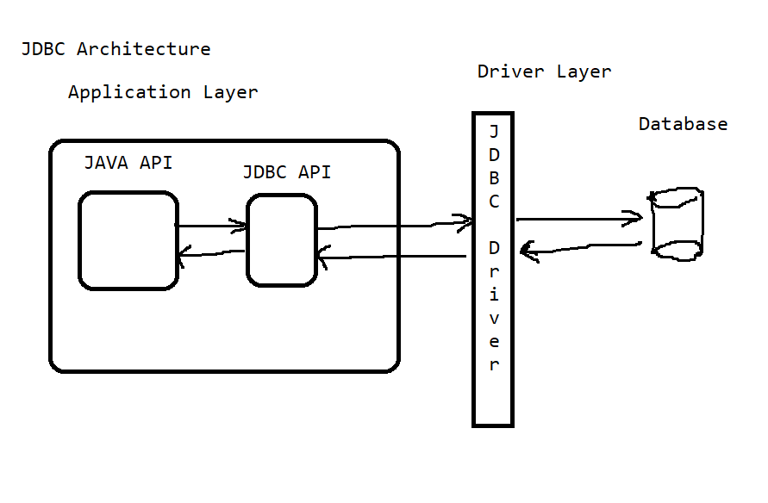

JDBC API Steps:

1. import java.sql.*;
2. Load the driver

Class.forName(“DriverClassName”);

Or

DriverManager.registerDriver(driver_obj);

1. Establishing a database connection

Connection con = DriverManager.getConnection(“url”, “username”, “password”);

1. Create a statement

Statement st = con.createStatement();

//to run any number of different queries

PreparedStatement pst = con.prepareStatement(“sql”);

// to run a single sql command for more than one time

CallableStatement cst = con.prepareCall(“sql”);

// to run a PL/SQL stored programs

1. Execute the command

boolean b = st.execute(“query”); | pst.execute();

// for DDL commands

// or when you don’t know the query

// b -> true - the query was select command

// b -> false- DML command

ResultSet rs = st.executeQuery(“query”) | pst.executeQuery();

// for SELECT Command

int count = st.executeUpdate(“query”); | pst.executeUpdate();

// for DML commands

1. Close the resources

rs.close();

st.close();

con.close();

1. Handle the exceptions

* Generally occurred exceptions are:
  + ClassNotFoundException
  + SQLException